**TYPE:** TEST

**TASK 1: Scientific Method and Cells Structure and Function Test (48 marks)**

Students will complete a number of questions relating to investigating scientifically. These questions will address the investigating process as well as analysis of second hand data. This task will be completed in one session under test conditions.

**Time for the task (1 hour)**

* 5 minutes reading time
* 55 minutes working time

**What you need to do:**

* Follow the instructions provided very carefully to complete the test.
* Draw any results in pencil and answer all questions given.
* It is your responsibility to organise your time effectively.
* There is to be no discussion between you or any of your class mates.
* No sharing of any equipment or answers at all.

|  |  |
| --- | --- |
| **Requirements for assessment** | **Date:** |
| Complete all questions | _**__________________** |

|  |  |  |
| --- | --- | --- |
| Section | Marks available | Your Marks |
| A – Multiple Choice | 16 |  |
| B – Short Answer | 32 |  |
| Total | 48 | = % |

**DO NOT TURN THIS PAGE OVER UNTIL YOU ARE TOLD TO**

**STUDENT NAME: _______________________________________________________**

**YEAR: 11**

**TEACHER: Ms Andrews Mr Schembri (circle)**

**Scientific Method and Cells, Structure and Function Test**

**Section A - Multiple Choice**

**Instructions: Record the letter of your answer on the Multiple Choice Answer Sheet provided.**

1. The basic structural unit units of life are:

a. tissue

b. organs

c. systems

d. cells

2. What is the name given to the variable that is measured in an investigation?

a. dependent variable

b. highly variable

c. independent variable

d. the measurement

3. The series of interconnecting canals that transport fluid through a cell are called

a. endoplasmic reticulum

b. centrioles

c. golgi bodies

d. mitochondria

4. The mitochondria:

a. give rise to the endoplasmic reticulum

b. are usually doubled-layered organisms with finger like extensions

c. are the centre of RNA synthesis

d. are the centres of cellular respiration

5. Mammalian sperm cells expend a large amount of energy in moving through the female reproductive tract. On the basis of this information you would predict that these cells would contain a large number of:

a. vacuoles

b. mitochondria

c. ribosomes

d. chloroplasts

6. The organelles of the cell are concerned with essential processes, one of which is the synthesis of protein. This particular organelle is the

a. ribosome

b. Golgi body

c. nucleolus

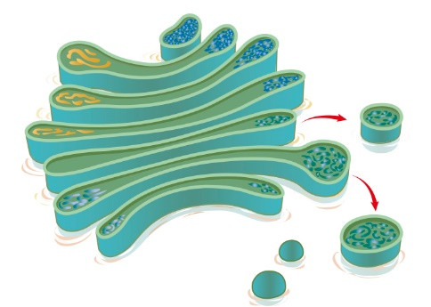 d. endoplasmic reticulum

7. What is the structure shown in the picture?

a. endoplasmic reticulum

b. Golgi body

c. vacuole

d. lysosome

8. All cells obtain energy for their general metabolic activity by the oxidation of glucose. This basic process is known as cellular

a. reproduction

b. respiration

c. photosynthesis

d. metabolism

9. Students observed some cheek cells under a microscope, using a 10x ocular and a 40x objective lens. If the same ocular lens, but a 10x objective lens was used, what would happen to the field of view?

a. it would increase

b. it would decrease

c. it would remain the same

d. it would change shape

10. The following diagram shows three cells at a magnification of x400. The field of view (FOV) is 0.5mm. Approximately four of the cells labelled ‘A’ can fit across the FOV at this magnification. In micrometres, how large is cell ‘A’ ?

 a. 12.5 m

b  m

A

c  m

d  m

11. If 8 cells fill the field of view on 100x magnification, how many of the same cells will fill the field of view on 400x magnification?

a. 32

b. 2

c 8

d impossible to tell as cells vary in size

12. When using a compound microscope, light travels to your eye passing through the following parts of the microscope in the order:

a. ocular, objective lens, diaphragm, mirror

b. mirror, diaphragm, base, ocular

c. mirror, diaphragm, objective lens, ocular

d. ocular, diaphragm, mirror, objective lens

13 Which of the following is **not** a good way to obtain reliable results from an experiment?

a. Use a large sample.

b. Use a small sample

c. Test a large population

d. Repeat the experiment several times.

14. Scientific research must be conducted in an ethical manner. Which of the following statements identifies behaviour that would be classified as unethical?

a. Informing participants that they are free to withdraw from the experiment whenever they wish

b. Giving participants sufficient information so they could give informed consent

c. Making sure that the participants remain anonymous.

d. Telling the participants that if they become part of the study that they must continue through to the end

15. A runner is on a training camp at the beach. The very first morning before breakfast, they go on a 9 kilometre run through the sand dunes. The runner covers the 9 kilometre trail in a time of 38 minutes. After a week of intense training, the runner can now do the trail in a time of 33 minutes. The percentage change for the athlete’s time was:

a. 23.6%

b. **-** 13.2%

c. 0.132%

d. 13.2%

16. A chemical was analysed and found to contain: 10% sodium, 30% potassium, 40% oxygen

15% magnesium and 5% other elements. The LEAST appropriate way to display this information is:

a. table

b. column graph

c. pie chart

d. line graph

.

**Section B – Short Answer**

**Instructions: Write your answers in the space provided in this booklet.**

1. A drug ‘LBP’, which is administered intravenously, increases the depth of breathing in patients suffering from asthma. In response to patients who dislike injections a new formulation of LBP has been developed which can be administered as an inhalant. Design an experiment (**by answering the following questions**) to test whether the new formulation is an effective treatment.
   1. State a suitable hypothesis (1 mark)

The inhalant formulation of LBP is more effective than the intravenous formulation in increasing a patients’ depth of breathing.

* 1. What would be the independent variable? (1 mark)

Formulation of LBP

* 1. What would be the dependent variable? (1 mark)

Depth of breathing

* 1. What treatment would your experimental group receive? (1 mark)

Inhalant formulation

* 1. What would a suitable control be? (1 mark)

No treatment at all OR treatment already being used e.g. intravenous

* 1. Why have a control group? (1 mark)

To provide base data for comparison

* 1. What treatment would they receive? (1 mark)

None OR intravenous formulation of LBP

* 1. State at least four variables that need to be controlled. (2 marks)

Age of patients Amount of LBP (dosage) Weight of patients

Time of administration Asthmatic or not

* 1. Explain how you could increase the reliability of your experiment. (1 mark)

Replicate three or more times Increase number of subjects

**2.** The data presented in the table below was recorded during an experiment in which the experimenter varied the concentration of carbon dioxide (CO2) in the air breathed by the subject, to see what effect it would have on the subject’s breathing rate.

|  |  |
| --- | --- |
| **Percentage CO2** | **Breathing rate (breaths/minute)** |
| 1.0 | 14 |
| 1.5 | 15 |
| 2.0 | 15 |
| 3.0 | 15 |
| 5.5 | 16 |
| 6.0 | 27 |

(i) State a hypothesis which is being investigated in this experiment. (1 mark)

___________as the concentration of CO2 increases the breathing rate of the subject would increase

__________ Increasing the concentration of carbon dioxide will increase a subjects’ breathing rate.

OR

vice versa ________________________________________________________________________

(ii) What is the independent variable? (1 mark)

___________percentage CO2 / concentration of CO2

________________________________________________________________________________________

(iii) What is the dependent variable? (1 mark)

___________breathing rate

________________________________________________________________________________________

1. Plot a line graph on the graph paper below to display the data in the table. (4 marks)

1 mark for title – with both variables mentioned

1 mark for even scales

1 mark for axis labels – including units

1 mark for plot and line drawn (no zero point)

Must have all parts to get the full mark

* E.g. if only one axis labelled, then no mark.

If they have the axes around the wrong way then zero – but may get 1 if title correct (but not axes –because they are not correct –in wrong position)

1. Would a prediction of the breathing rate at 4% carbon dioxide be likely to be more or less accurate than a prediction of breathing rate at 7% carbon dioxide? Explain your answer.

(2 marks)

__________ More accurate as interpreting data.

Breathing rate of 7% involves extrapolating data or guessing / estimating.

_______________________________________________________________________________

________________________________________________________________________________________

1. What are **THREE** variables which would have been controlled in this experiment. Explain.

(3 marks)

_______

Amount of carbon dioxide given Time exposed to carbon dioxide

Time breathing rate is recorded for ___________________

________________________________________________________________________________________

________________________________________________________________________________________

________________________________________________________________________________________

3. For the numbered parts of the animal cell diagram in the table which follows, name each part and describe it’s function. (10 marks)

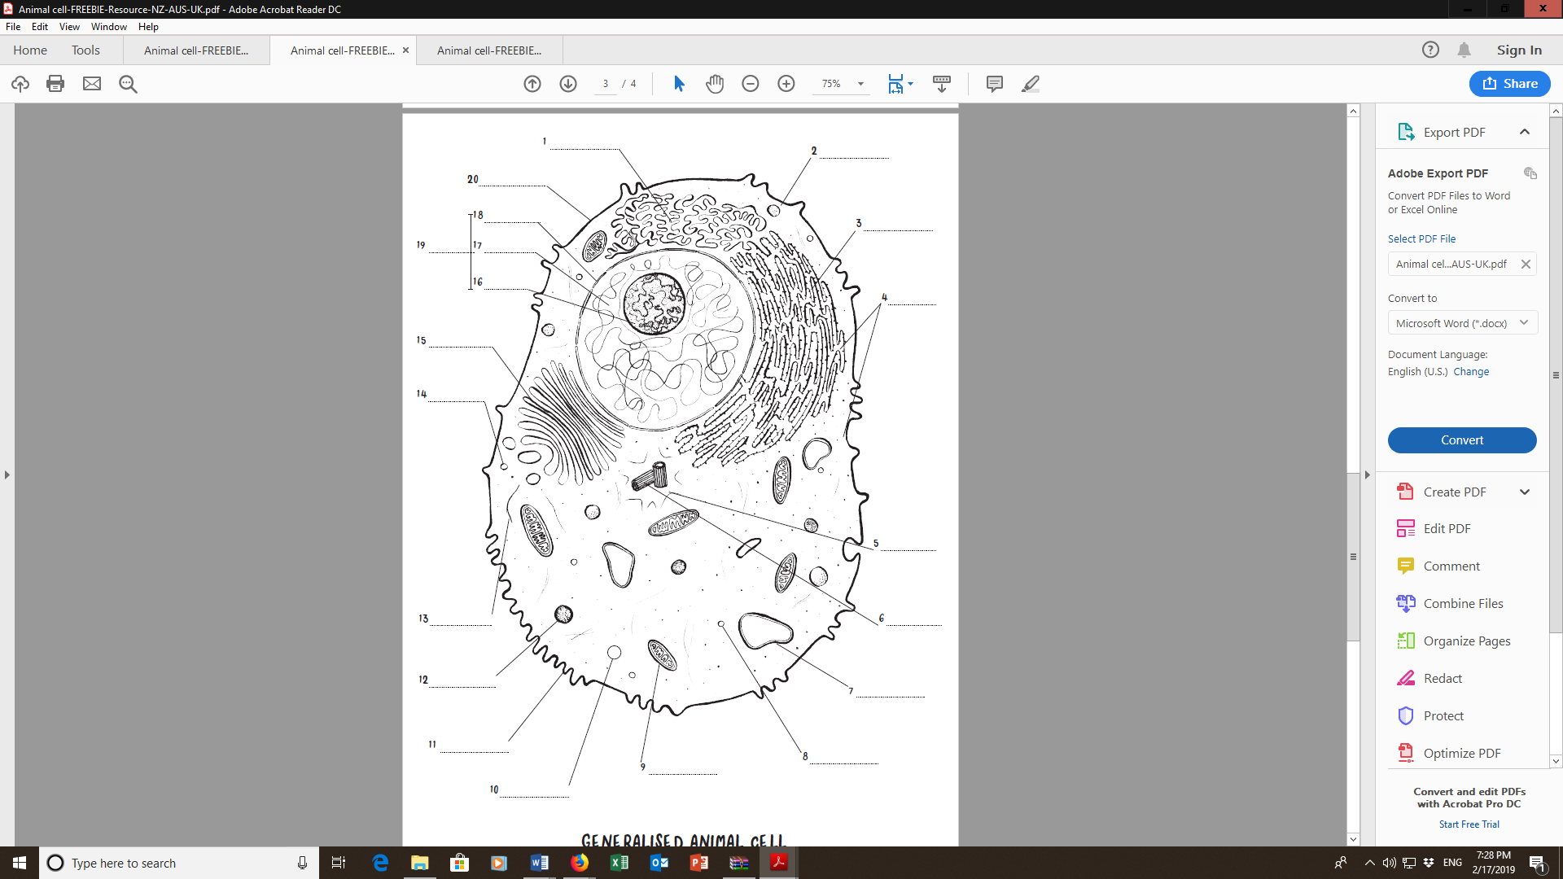

|  |  |  |
| --- | --- | --- |
| Numbered part | Name | Function. |
| 4 | ribosomes | Site at which amino acids are joined together to make proteins |
| 9 | mitochondrion | Site of reactions involved in cellular respiration – produce energy for the cell’s activities |
| 14 | lysosome | Formed from Golgi body, they are small spheres  containing digestive enzymes…   * able to break down large molecules. * Can join with vesicles and break down material inside * Can digest worn out organelles. |
| 19 | Nucleus | * Holds DNA which contains inherited information …DNA -has the information which says what type of proteins a cell can make * Control’s the structure of a cell and the way it functions |
| 20 | Cell membrane | * Outer boundary of the cell –separates cell contents from the external environment * Determines which substances get into or out of the cell. |

**2 x 5 = 10**

END OF TEST

SPARE GRAPH PAPER